PROJECT REPORT ON

**IOT BASED PATIENT HEALTH MONITORING SYSTEM**

**A Project Report**

Submitted in partial fulfillment of the  
requirements for the award of the Degree of

**BACHELOR OF SCIENCE (INFORMATION TECHNOLOGY)**

**By**

ABDULLAH MOHD RAEES

Seat Number: _______________

AYESHA BI ABDUL NADIR KHAN

Seat Number: _______________

**Under the esteemed guidance of**

**Mr. SABIR SHAIKH**

**Assistant Professor, Department of Information Technology**



**DEPARTMENT OF INFORMATION TECHNOLOGY**

**VIDYALANKAR SCHOOL OF INFORMATION TECHNOLOGY**

**(Affiliated to University of Mumbai)**

**MUMBAI, 400 037**

**MAHARASHTRA**

**2018-2019**

**VIDYALANKAR SCHOOL OF INFORMATION TECHNOLOGY**

**(Affiliated to University of Mumbai)**

**MUMBAI-MAHARASHTRA-400037**

**DEPARTMENT OF INFORMATION TECHNOLOGY**



**CERTIFICATE**

This is to certify that the project entitled, **"IOT BASED PATIENT MONITORING SYSTEM "**, is bonafied work of **ABDULLAH MOHD RAEES** bearing Seat No: __________________ submitted in partial fulfilment of the requirements for the award of degree of BACHELOR OF SCIENCE in INFORMATION TECHNOLOGY from University of Mumbai.

**Internal Guide Coordinator**

**Internal Examiner External Examiner**

**Date: College Seal Principal**

PROFORMA FOR THE APPROVAL PROJECT PROPOSAL

PNR No: ___________________________Roll no: ______________

1. Name of the Student

___________________________________________________

1. Title of the Project

___________________________________________________

1. Name of the Guide

___________________________________________________

1. Teaching experience of the Guide

___________________________________________________

1. Is this your first submission? Yes No

Signature of the Student Signature of the Guide

___________________ ____________________

Date: ______________ Date: _______________

Signature of the Coordinator

________________________

Date: ___________________

**ABSTRACT**

The Internet of Things (IoT) has been widely used to interconnect the available medical resources and offer smart, reliable, and effective healthcare service to the elderly people. Patient monitoring for active and assisted living is one of the paradigms that can use the IoT advantages to improve the elderly lifestyle. In this paper, we present an IoT architecture customized for healthcare applications. The proposed architecture collects the data and relays it to the cloud where it is processed and analyzed. Feedback actions based on the analyzed data can be sent back to the user. A prototype of the proposed architecture has been built to demonstrate its performance advantages.

**ACKNOWLEDGEMENT**

*The success and final outcome of our project “****IOT BASED PATIENT MONITORING SYSTEM****” required a lot of guidance and assistance from many people and we are extremely privileged to have got this all along the completion of our project. All that we have done is only due to such supervision and assistance and we would not forget to thank them.*

*Firstly we are very thankful to our guide* ***mr. Sabir shaikh****, for guiding us to do the project work on time and giving us all support and guidance which made us complete the project duly. We are extremely thankful to him for providing such a nice support and guidance.*

*We are also thankful to and fortunate enough to get constant encouragement, support and guidance from the teachers of information technology who helped us in successfully completing our project work.*

**DECLARATION**

I hereby declare that the project entitled, “***IOT BASED PATIENT HEALTH MONITORING SYSTEM***” done at Vidyalankar School of Information Technology, has not been in any case duplicated to submit to any other universities for the award of any degree. To the best of my knowledge other than me,no one has submitted to any other university.

The project is done in partial fulfillment of the requirements for the award of degree of **BACHELOR OF SCIENCE (INFORMATION TECHNOLOGY)** to be submitted as final semester project as part of our curriculum.

Name and Signature of the Student

# INDEX

1 INDEX 7

1 INTRODUCTION 8

1.1 BACKGROUND 9

1.2 OBJECTIVES 9

1.3 PURPOSE , SCOPE , APPLICABILITY 10

1.3.1 PURPOSE 10

1.3.2 SCOPE 10

1.3.3 APPLICABILITY 11

1.4 ACHIEVEMENTS 11

1.5 ORGANISATION OF REPORT 11

2 SURVEY OF TECHNOLOGIES 12

3 REQUIREMENT AND ANALYSIS 15

3.1 PROBLEM DEFINITION 15

3.2 REQUIREMENTS SPECIFICATION 16

3.3 PLANNING AND SCHEDULING 17

3.4 SOFTWARE AND HARDWARE REQUIREMENT 17

3.4.1 HARDWARE REQUIREMENT 17

3.4.2 SOFTWARE REQUIREMENT 24

3.5 24

3.6 PRELIMINARY PRODUCT DESCRIPTION 24

3.7 CONCEPTUAL MODELS 26

4 SYSTEM DESIGN 27

4.1 FLOW CHART 28

4.2 BLOCK DIAGRAM 29

4.3 DATA FLOW DIAGRAM 30

4.4 USE CASE DIAGRAM 31

4.5 SEQUENCE DIAGRAM 32

4.6 ACTIVITY DIAGRAM 33

4.7 CIRCUIT DIAGRAM 34

4.8 USER INTERFACE 35

4.9 SECURITY ISSUES 35

**TABLE OF FIGURES**

Figure 1 GANTT CHART: 18

Figure 2: Arduino Uno R3 19

Figure 3: DHT11 (Temprature and Humidity Sensor) 20

Figure 4: Pulse Sensor 21

Figure 5: Bread Board 22

Figure 6: 16 x 2 LCD Display 23

Figure 7: Jump Wires 23

Figure 8: ESP8266 WIFI 24

Figure 9: Power Supply 25

Figure 10: Conceptual Model 28

Figure 11 : Flow Chart 30

Figure 12 : Block Diagram 31

Figure 13: Data Flow Diagram 32

Figure 14 : Use Case Diagram 33

Figure 15 : Sequence Diagram 34

Figure 16 : Activity Diagram 35

Figure 17 : Circuite Diagram 36

Figure 18 : User Interface 37

**CHAPTER 1.**

# INTRODUCTION

Monitoring the various parameters of the patient in hospital using the internet of things.Health Monitoring system is based on the internet of things ,the patient data is sends to the cloud server ,stores on the particular channel.

The data on the channel shows in the graph format even the data can be gets on the mobile app and the doctor can be gets it monitoring purpose anywhere in the place,even can alert the doctors signal goes down to particular level of the corresponding patient.

## BACKGROUND

* In recent days, various IoT systems were developed for health monitoring systems.
* A real-time application was presented with distributed flow environment for the IoT healthcare. When the person under observation moves beyond range, data will be recorded in the local server and communicated later.
* Patients will be given with the necessary wearable sensors capable of measuring Humidity,Temperature, and Heart Beat to measure these health parameters.

## OBJECTIVES

* An adjustable, wearable providing continuous monitoring of a large number of sensors each one measuring various physiological signals, like Temperature , Humidity and Heart beat etc,.
* The system automatically alerts the user about the patient’s status over IOT and also shows details of heartbeat and temperature of patient live over the internet.
* IOT based patient health tracking system effectively uses internet to monitor patient health stats and save lives on time
* Study and develop end to end communication between patient and relative or doctor.
* Integration of Pulse sensor, Temperature and Humidity sensor in a single system.

## PURPOSE , SCOPE , APPLICABILITY

### PURPOSE

* Monitoring your beloved ones becomes a difficult task in the modern day life. Keeping track of the health status of the patient at home is a difficult task. Especially old aged patients should be periodically monitored and their loved ones need to be informed about their health status from time to time while at work.
* So we propose an innovative system that automated this task with ease. Our system puts forward a smart patient health tracking system that uses Sensors to track patient health and uses internet to inform their health status to the doctor.

### SCOPE

* IoT has enabled healthcare monitoring to become more widespread and effective. In the past, patients could only be monitored in a medical facility or under the care of family or home nurses.
* **Health sensors that attach to the body can now transmit vitals and teach patients to be proactive about their health while cutting care costs and fostering improved doctor/patient relationships.**

### APPLICABILITY

* It can be also used in old age homes to monitor the various parameters of a sick person in old age homes.

## ACHIEVEMENTS

## ORGANISATION OF REPORT

**CHAPTER 2.**

# SURVEY OF TECHNOLOGIES

**2.**SURVEY OF TECHNOLOGIES

A program for Arduino may be written in any programming language with compilers that produce binary machine code for the target processor. Atmel provides a development environment for their microcontrollers, AVR Studio and the newer Atmel Studio. The Arduino project provides the Arduino integrated development environment (IDE), which is a cross-platform application written in the programming language Java. A program written with the IDE for Arduino is called a *sketch*.] Sketches are saved on the development computer as text files with the file extension *.ino*. Arduino Software (IDE) pre-1.0 saved sketches with the extension *.pde*.

The Arduino IDE supports the languages C and C++ using special rules of code structuring. The Arduino IDE supplies a software library from the Wiring project, which provides many common input and output procedures. User-written code only requires two basic functions, for starting the sketch and the main program loop, that are compiled and linked with a program stub *main()* into an executable cyclic executive program with the GNU toolchain, also included with the IDE distribution.

**CHAPTER 3.**

# REQUIREMENT AND ANALYSIS

**3.REQUIREMENT AND ANALYSIS**

## PROBLEM DEFINITION

* The main problem for poor people is dangerous and emergency health care service at dangerous event. In today’s health care system for the patients who stays in home is not reactive so there is a need to develop the system which is reactive in nature.
* In current existing health care system due to lack of awareness , poor facility with undeveloped technologies .it the need of the smart health care system . On network hospital help patients and doctors for remote handling of services.
* Nearly 27% of the total deaths in india happen with no medical attention at the time of death, according to the 2013 civil registration data released by the census directorate. Data based on 27 states and union territories also indicated that only 43% of the total death happen in institution and only 3.9% of the rest under the care of a qualified doctor.

## REQUIREMENTS SPECIFICATION

* Application must have a module for login using unique credentials of a patient for the doctor to monitor patient’s vital data.
* Application must have a module for login using unique credentials of a patient for Guardian/Caretaker to monitor patient’s vital data.
* Messaging Service: Hardware must have wifi module which send’s Email alert messages to doctor and guardians upon any emergencies. And application must send email alerts upon any emergencies.
* Web application must be user friendly, simple and interactive.
* The user interface is designed in such way that novice users with little knowledge of web, should be able to access this application.

## PLANNING AND SCHEDULING

* **GANTT CHART.**

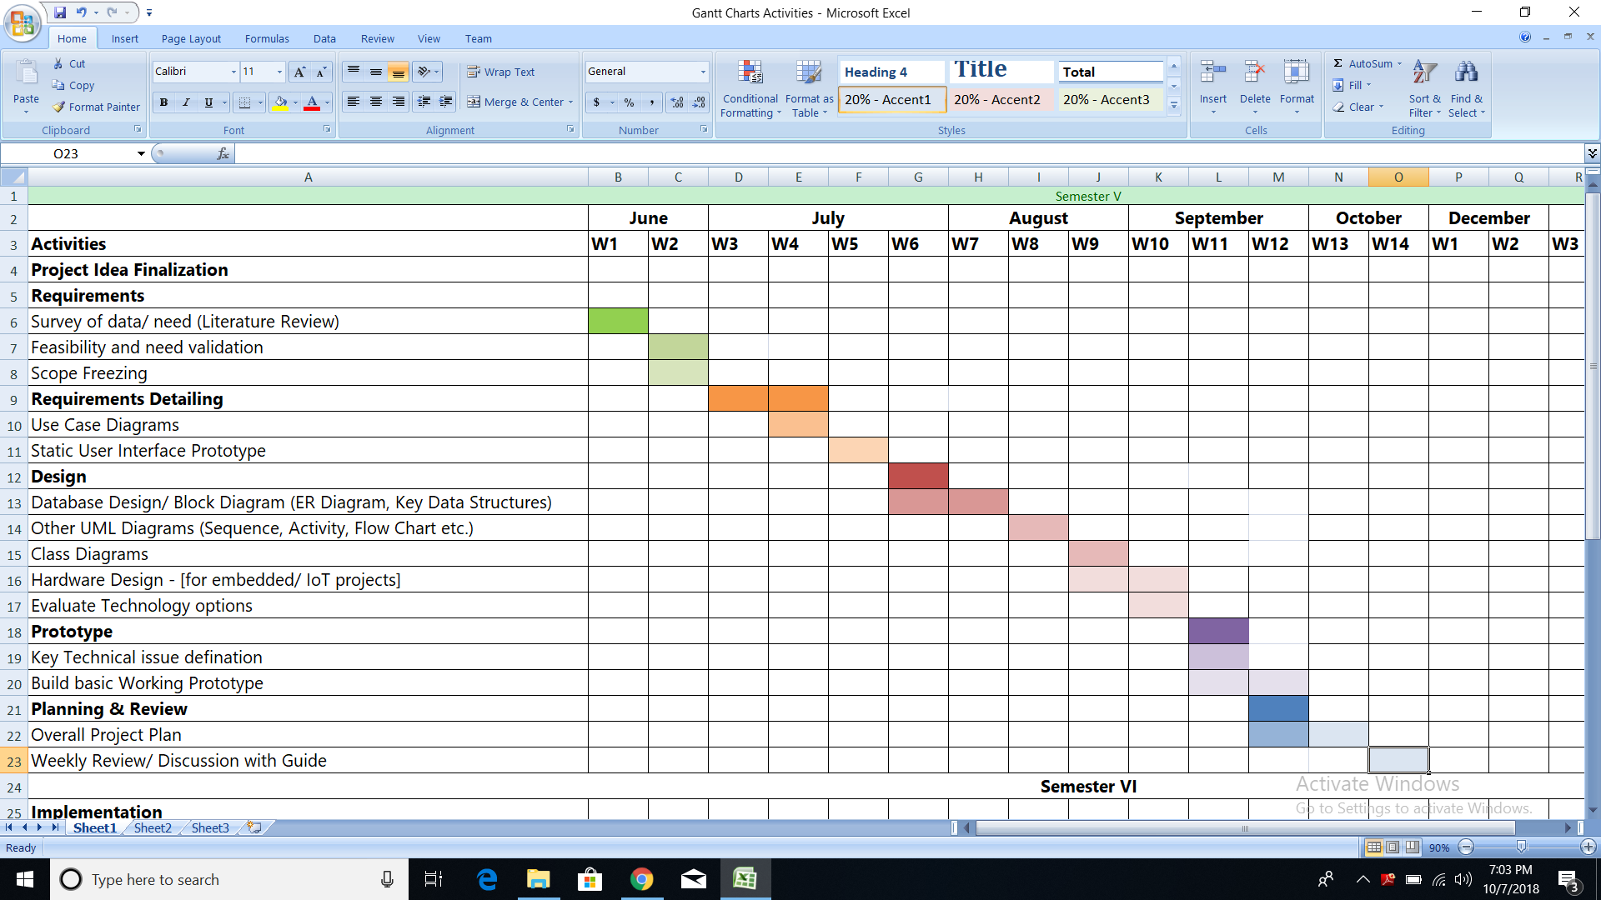

Figure 1 GANTT CHART:

## SOFTWARE AND HARDWARE REQUIREMENT

### HARDWARE REQUIREMENT

**1. Arduino Micro controller**

Arduino Uno is a microcontroller board based on the ATmega328P. It has 14 digital input/output pins (of which 6 can be used as PWM outputs), 6 analog inputs, a 16 MHz quartz crystal, a USB connection, a power jack, an ICSP header and a reset button. It contains everything needed to support the microcontroller; simply connect it to a computer with a USB cable or power it with a AC-to-DC adapter or battery to get started.



Figure 2: Arduino Uno R3

Starting clockwise from the top center:

1. Analog Reference pin

2. Digital Ground

3. Digital Pins 2-13

4. Digital Pins 0-1/Serial In/Out - TX/RX (dark green) - These pins cannot be used for digital i/o (digitalRead and digitalWrite) if you are also using serial communication (e.g. Serial.begin).

5. Reset Button - S1

6. In-circuit Serial Programmer

7. Analog In Pins 0-5

8. Power and Ground Pins

9. External Power Supply In (9-12VDC) - X1

10. Toggles External Power and USB Power (place jumper on two pins closest to desired supply) - SV1

11. USB (used for uploading sketches to the board and for serial communication between the board and the computer; can be used to power the board)

**2.DHT11 (TEMPRATURE AND HUMIDITY SENSOR)**

The DHT11 is a basic, ultra low-cost digital temperature and humidity sensor. It uses a capacitive humidity sensor and a thermistor to measure the surrounding air, and spits out a digital signal on the data pin (no analog input pins needed). Its fairly simple to use, but requires careful timing to grab data. The only real downside of this sensor is you can only get new data from it once every 2 seconds, so when using our library, sensor readings can be up to 2 seconds old.

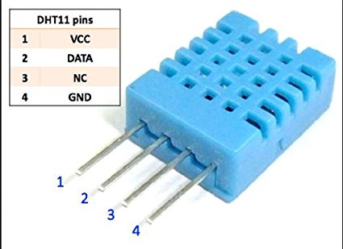

Figure 3: DHT11 (Temprature and Humidity Sensor)

**3.PULSE SENSOR**

Pulse Sensor is a plug-and-play heart-rate sensor for Arduino. It can be used by students, artists, makers, and developers who want live heart-rate data into their projects. The Pulse Sensor Kit includes: 1) Soft braided-wire ribbon cable.

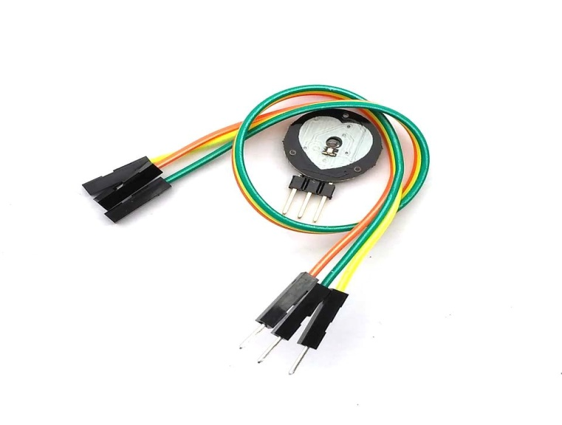

Figure 4: Pulse Sensor

**4.BREAD BOARD**

A breadboard is a construction base for prototyping of electronics. Originally it was literally a bread board, a polished piece of wood used for slicing bread.

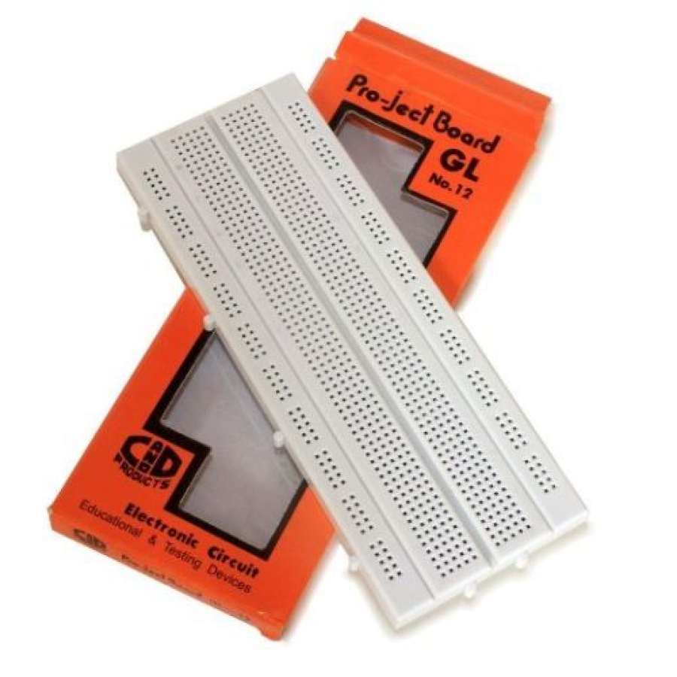

Figure 5: Bread Board

**5. 16 x 2 LCD DISPLAY**

LCD (Liquid Crystal Display) screen is an electronic display module and find a wide range of applications. A 16x2 LCD display is very basic module and is very commonly used in various devices and circuits. These modules are preferred over seven segments and other multi segment LEDs. The reasons being: LCDs are economical; easily programmable; have no limitation of displaying special & even custom characters (unlike in seven segments), animations and so on.

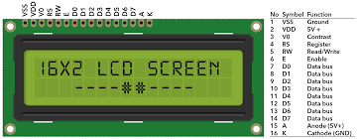

Figure 6: 16 x 2 LCD Display

**6. JUMP WIRES (MALE TO MALE & MALE TO FEMALE )**

A jump wire (also known as jumper, jumper wire, jumper cable, DuPont wire, or DuPont cable – named for one manufacturer of them) is an electrical wire, or group of them in a cable, with a connector or pin at each end (or sometimes without them – simply "tinned"), which is normally used to interconnect the components of a breadboard or other prototype or test circuit, internally or with other equipment or components, without soldering.

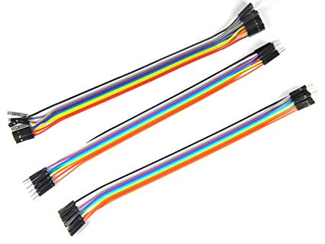

Figure 7: Jump Wires

**7.ESP8266 WIFI**

ESP8266 is all about Wi-Fi. If you are eager to connect your new ESP8266 module to Wi-Fi network to start sending and receiving data, this is a good place to start. If you are looking for more in depth details of how to program specific Wi-Fi networking functionality, you are also in the right place.

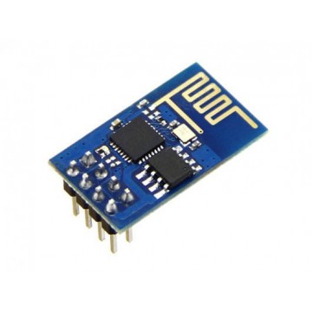

Figure 8: ESP8266 WIFI

**8.POWER SUPPLY (9V BATTERY)**

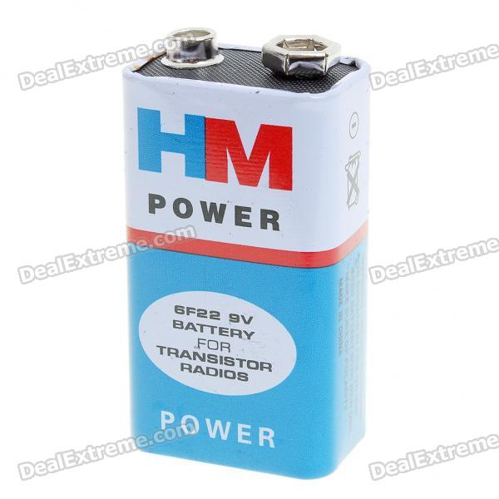The nine-volt battery, or 9-volt battery, is a common size of battery that was introduced for the early transistor radios. It has a rectangular prism shape with rounded edges and a polarized snap connector at the top. This type is commonly used in walkie-talkies, clocks and smoke detectors.

Figure 9: Power Supply

### SOFTWARE REQUIREMENT

• Operating System: Windows 7 or higher

• Platform: IoT Cloud

• IDE: Arduino 1.8.4

## 

## PRELIMINARY PRODUCT DESCRIPTION

**1.Functional Requirements**

• Application must have a module for login using unique credentials of a patient for the doctor to monitor patient’s vital data.

• Messaging Service: Hardware must have WIFI module which send’s EMAIL alert messages to doctor and guardians upon any emergencies. And application must send email alerts upon any emergencies.

**2. Non-Functional Requirements**

Non-functional requirements are not directly related to the functional behavior of the system.

• Web application must be user friendly, simple and interactive.

• The user interface is designed in such way that novice users with little knowledge of web, should be able to access this application.

**3. Software Specifications**

• Operating System: Windows 7 or higher

• Platform: IoT Cloud

• IDE: Arduino 1.8.4

• Database: MySQL

• Technologies used: C++, SQL, PHP

**4. Hardware Specifications**

• Microcontroller: Arduino Uno Board

• Sensors: DHT11 (Temperature and Humidity ), Pulse .

• Processor: Pentium IV or higher

• Processor speed: 1.6GHz

• RAM: 512 MB

• Disk Space: 250 MB or higher

## CONCEPTUAL MODELS

A conceptual model is a representation of a system, made of the composition of concepts which are used to help people know, understand, or simulate a subject the model represents.

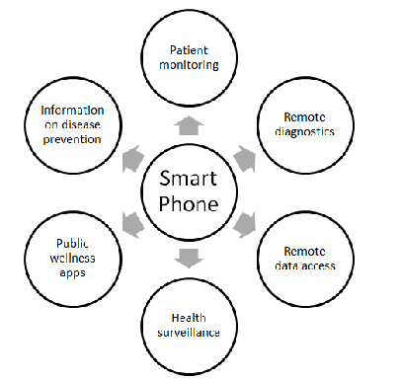

Figure 10: Conceptual Model

**CHAPTER 4.**

# SYSTEM DESIGN

## FLOW CHART

A flowchart is a type of diagram that represents an algorithm, workflow or process. The flowchart shows the steps as boxes of various kinds, and their order by connecting the boxes with arrows. This diagrammatic representation illustrates a solution model to a given problem.

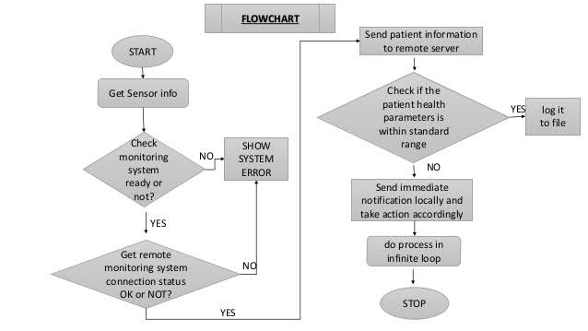

Figure 11 : Flow Chart

## BLOCK DIAGRAM

A block diagram is a diagram of a system in which the principal parts or functions are represented by blocks connected by lines that show the relationships of the blocks.[[1]](https://en.wikipedia.org/wiki/Block_diagram#cite_note-SSEV-1) They are heavily used in engineering in hardware design, electronic design, software design, and process flow diagrams.

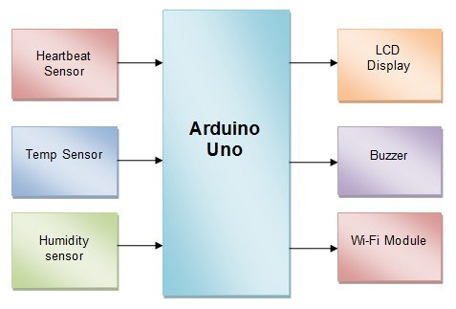

Figure 12 : Block Diagram

## DATA FLOW DIAGRAM

A data flow diagram (DFD) is a graphical representation of the "flow" of data through an information system, modelling its process aspects. ADFD is often used as a preliminary step to create an overview of the system without going into great detail, which can later be elaborated.

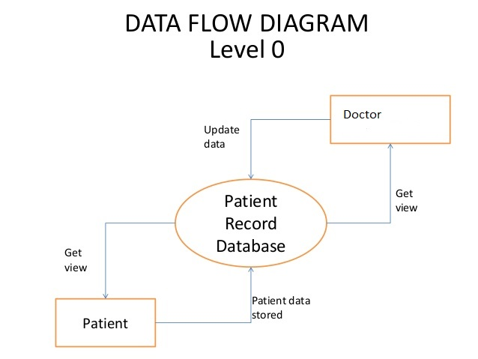

Figure 13: Data Flow Diagram

## USE CASE DIAGRAM

UML Use Case Diagrams. Use case diagrams are usually referred to as behavior diagrams used to describe a set of actions (use cases) that some system or systems (subject) should or can perform in collaboration with one or more external users of the system (actors).

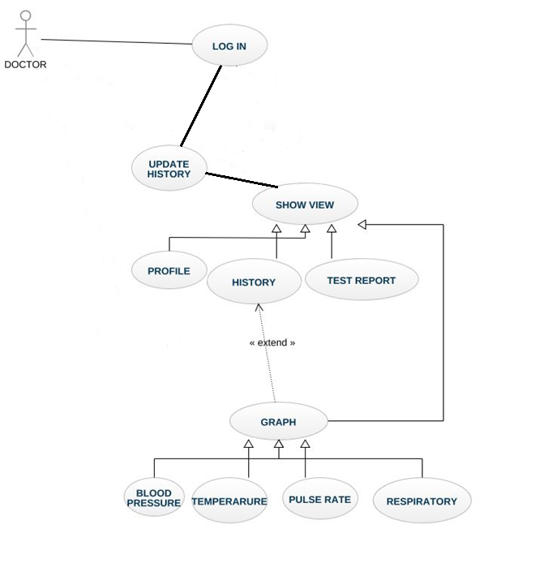

Figure 14 : Use Case Diagram

## SEQUENCE DIAGRAM

Sequence diagrams are sometimes called event diagram event scenarios. A sequence diagram shows, as parallel vertical lines (lifelines), different processes or objects that live simultaneously, and, as horizontal arrows, the messages exchanged between them, in the order in which they occur.

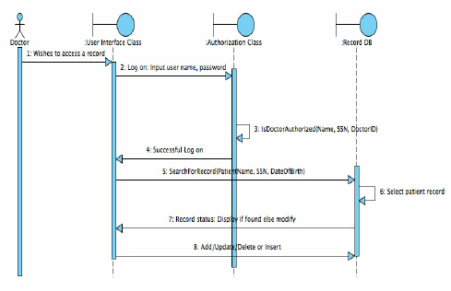

Figure 15 : Sequence Diagram

## ACTIVITY DIAGRAM

Activity diagram is another important diagram in UML to describe the dynamic aspects of the system. Activity diagram is basically a flowchart to represent the flow from one activity to another activity. The activity can be described as an operation of the system. The control flow is drawn from one operation to another.

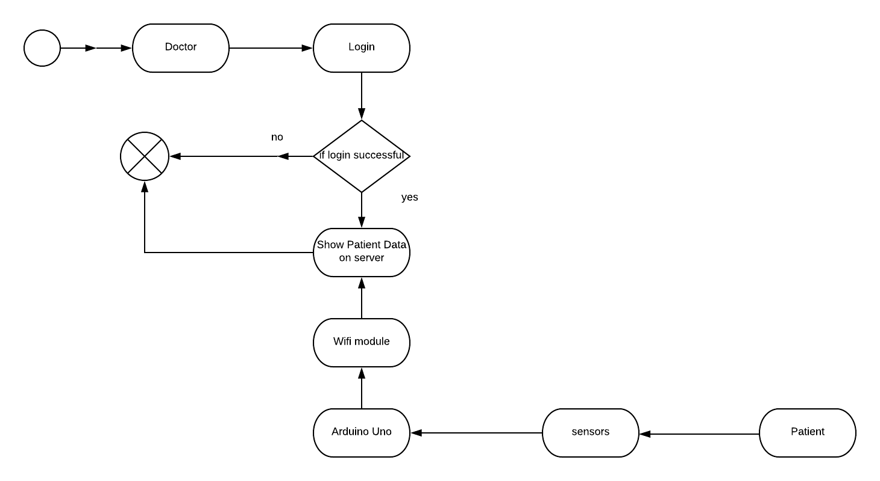

Figure 16 : Activity Diagram

## CIRCUIT DIAGRAM

A circuit diagram (electrical diagram, elementary diagram, electronic schematic) is a graphical representation of an electricalcircuit.

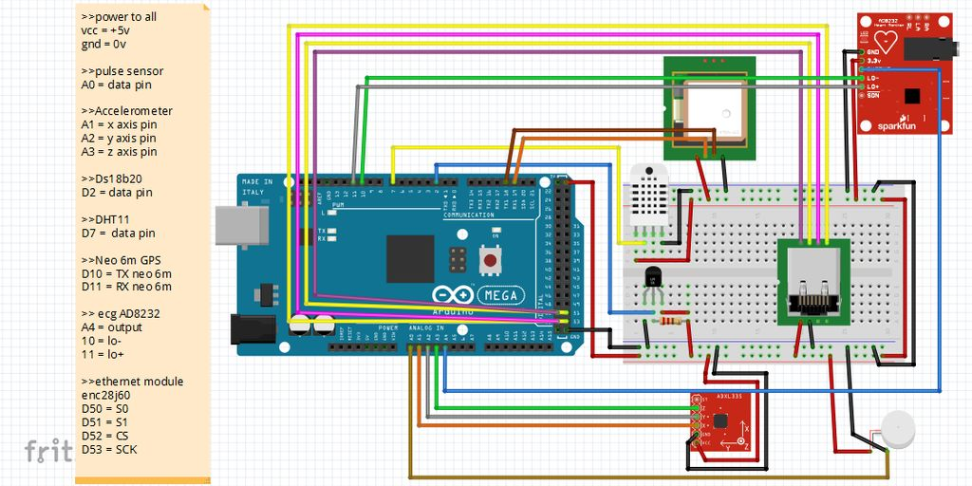

Figure 17 : Circuite Diagram

## USER INTERFACE

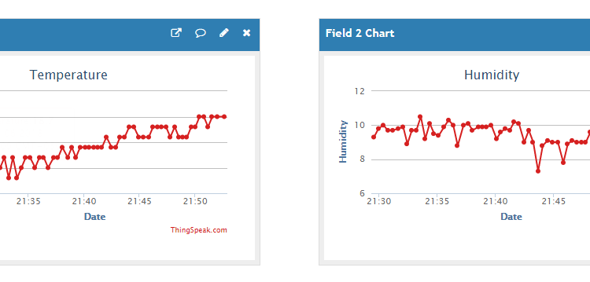

Figure 18 : User Interface

## SECURITY ISSUES

* From a system point of view, transferring complete and accurate information from the patient to the hospital is always necessary. Failure to do so may cause a threat to the patient’s health.
* People with bad intentions can send wrong data to the hospital by miss tilising the devices. The quality of data may also vary depending upon the quality of communication links. The data from BAN is sent using public communication infrastructures to the hospital. Hence, data authentication is also very important.
* Data security and patient’s privacy are certainly the important challenges in the deployment of PMS. In order to highlight specific security requirements in PMS, we analyse the system as a sequence of segments, identify related security requirements, vulnerabilities, threats and attacks of each segment, and possible security solutions for identified issues.